library(tidyverse)

## -- Attaching packages --------------------------------------- tidyverse 1.3.1 --

## v ggplot2 3.3.5 v purrr 0.3.4  
## v tibble 3.1.6 v dplyr 1.0.7  
## v tidyr 1.1.4 v stringr 1.4.0  
## v readr 2.1.0 v forcats 0.5.1

## -- Conflicts ------------------------------------------ tidyverse_conflicts() --  
## x dplyr::filter() masks stats::filter()  
## x dplyr::lag() masks stats::lag()

library(tidymodels)

## Registered S3 method overwritten by 'tune':  
## method from   
## required_pkgs.model_spec parsnip

## -- Attaching packages -------------------------------------- tidymodels 0.1.4 --

## v broom 0.7.10 v rsample 0.1.1   
## v dials 0.0.10 v tune 0.1.6   
## v infer 1.0.0 v workflows 0.2.4   
## v modeldata 0.1.1 v workflowsets 0.1.0   
## v parsnip 0.1.7 v yardstick 0.0.9   
## v recipes 0.1.17

## -- Conflicts ----------------------------------------- tidymodels_conflicts() --  
## x scales::discard() masks purrr::discard()  
## x dplyr::filter() masks stats::filter()  
## x recipes::fixed() masks stringr::fixed()  
## x dplyr::lag() masks stats::lag()  
## x yardstick::spec() masks readr::spec()  
## x recipes::step() masks stats::step()  
## * Learn how to get started at https://www.tidymodels.org/start/

library(GGally)

## Registered S3 method overwritten by 'GGally':  
## method from   
## +.gg ggplot2

library(ggcorrplot)

Iowa <- read_csv("ames_student (1).csv")

## Rows: 2053 Columns: 81

## -- Column specification --------------------------------------------------------  
## Delimiter: ","  
## chr (47): MS_SubClass, MS_Zoning, Street, Alley, Lot_Shape, Land_Contour, Ut...  
## dbl (34): Lot_Frontage, Lot_Area, Year_Built, Year_Remod_Add, Mas_Vnr_Area, ...

##   
## i Use `spec()` to retrieve the full column specification for this data.  
## i Specify the column types or set `show_col_types = FALSE` to quiet this message.

View(Iowa)  
summary(Iowa)

## MS_SubClass MS_Zoning Lot_Frontage Lot_Area   
## Length:2053 Length:2053 Min. : 0.00 Min. : 1300   
## Class :character Class :character 1st Qu.: 43.00 1st Qu.: 7500   
## Mode :character Mode :character Median : 62.00 Median : 9548   
## Mean : 57.38 Mean : 10258   
## 3rd Qu.: 78.00 3rd Qu.: 11600   
## Max. :313.00 Max. :215245   
## Street Alley Lot_Shape Land_Contour   
## Length:2053 Length:2053 Length:2053 Length:2053   
## Class :character Class :character Class :character Class :character   
## Mode :character Mode :character Mode :character Mode :character   
##   
##   
##   
## Utilities Lot_Config Land_Slope Neighborhood   
## Length:2053 Length:2053 Length:2053 Length:2053   
## Class :character Class :character Class :character Class :character   
## Mode :character Mode :character Mode :character Mode :character   
##   
##   
##   
## Condition_1 Condition_2 Bldg_Type House_Style   
## Length:2053 Length:2053 Length:2053 Length:2053   
## Class :character Class :character Class :character Class :character   
## Mode :character Mode :character Mode :character Mode :character   
##   
##   
##   
## Overall_Qual Overall_Cond Year_Built Year_Remod_Add  
## Length:2053 Length:2053 Min. :1875 Min. :1950   
## Class :character Class :character 1st Qu.:1953 1st Qu.:1965   
## Mode :character Mode :character Median :1972 Median :1993   
## Mean :1971 Mean :1984   
## 3rd Qu.:2000 3rd Qu.:2004   
## Max. :2010 Max. :2010   
## Roof_Style Roof_Matl Exterior_1st Exterior_2nd   
## Length:2053 Length:2053 Length:2053 Length:2053   
## Class :character Class :character Class :character Class :character   
## Mode :character Mode :character Mode :character Mode :character   
##   
##   
##   
## Mas_Vnr_Type Mas_Vnr_Area Exter_Qual Exter_Cond   
## Length:2053 Min. : 0.0 Length:2053 Length:2053   
## Class :character 1st Qu.: 0.0 Class :character Class :character   
## Mode :character Median : 0.0 Mode :character Mode :character   
## Mean : 103.8   
## 3rd Qu.: 164.0   
## Max. :1600.0   
## Foundation Bsmt_Qual Bsmt_Cond Bsmt_Exposure   
## Length:2053 Length:2053 Length:2053 Length:2053   
## Class :character Class :character Class :character Class :character   
## Mode :character Mode :character Mode :character Mode :character   
##   
##   
##   
## BsmtFin_Type_1 BsmtFin_SF_1 BsmtFin_Type_2 BsmtFin_SF_2   
## Length:2053 Min. :1.00 Length:2053 Min. : 0.00   
## Class :character 1st Qu.:3.00 Class :character 1st Qu.: 0.00   
## Mode :character Median :3.00 Mode :character Median : 0.00   
## Mean :4.21 Mean : 52.57   
## 3rd Qu.:7.00 3rd Qu.: 0.00   
## Max. :7.00 Max. :1526.00   
## Bsmt_Unf_SF Total_Bsmt_SF Heating Heating_QC   
## Min. : 0.0 Min. : 0 Length:2053 Length:2053   
## 1st Qu.: 226.0 1st Qu.: 793 Class :character Class :character   
## Median : 460.0 Median : 988 Mode :character Mode :character   
## Mean : 561.2 Mean :1055   
## 3rd Qu.: 801.0 3rd Qu.:1304   
## Max. :2336.0 Max. :5095   
## Central_Air Electrical First_Flr_SF Second_Flr_SF   
## Length:2053 Length:2053 Min. : 432 Min. : 0.0   
## Class :character Class :character 1st Qu.: 882 1st Qu.: 0.0   
## Mode :character Mode :character Median :1088 Median : 0.0   
## Mean :1168 Mean : 326.1   
## 3rd Qu.:1402 3rd Qu.: 701.0   
## Max. :5095 Max. :1862.0   
## Low_Qual_Fin_SF Gr_Liv_Area Bsmt_Full_Bath Bsmt_Half_Bath   
## Min. : 0.000 Min. : 480 Min. :0.0000 Min. :0.00000   
## 1st Qu.: 0.000 1st Qu.:1137 1st Qu.:0.0000 1st Qu.:0.00000   
## Median : 0.000 Median :1447 Median :0.0000 Median :0.00000   
## Mean : 4.973 Mean :1499 Mean :0.4301 Mean :0.05796   
## 3rd Qu.: 0.000 3rd Qu.:1737 3rd Qu.:1.0000 3rd Qu.:0.00000   
## Max. :1064.000 Max. :5095 Max. :3.0000 Max. :2.00000   
## Full_Bath Half_Bath Bedroom_AbvGr Kitchen_AbvGr   
## Min. :0.000 Min. :0.0000 Min. :0.000 Min. :1.000   
## 1st Qu.:1.000 1st Qu.:0.0000 1st Qu.:2.000 1st Qu.:1.000   
## Median :2.000 Median :0.0000 Median :3.000 Median :1.000   
## Mean :1.564 Mean :0.3751 Mean :2.855 Mean :1.047   
## 3rd Qu.:2.000 3rd Qu.:1.0000 3rd Qu.:3.000 3rd Qu.:1.000   
## Max. :4.000 Max. :2.0000 Max. :6.000 Max. :3.000   
## Kitchen_Qual TotRms_AbvGrd Functional Fireplaces   
## Length:2053 Min. : 3.000 Length:2053 Min. :0.000   
## Class :character 1st Qu.: 5.000 Class :character 1st Qu.:0.000   
## Mode :character Median : 6.000 Mode :character Median :1.000   
## Mean : 6.442 Mean :0.603   
## 3rd Qu.: 7.000 3rd Qu.:1.000   
## Max. :15.000 Max. :4.000   
## Fireplace_Qu Garage_Type Garage_Finish Garage_Cars   
## Length:2053 Length:2053 Length:2053 Min. :0.000   
## Class :character Class :character Class :character 1st Qu.:1.000   
## Mode :character Mode :character Mode :character Median :2.000   
## Mean :1.774   
## 3rd Qu.:2.000   
## Max. :5.000   
## Garage_Area Garage_Qual Garage_Cond Paved_Drive   
## Min. : 0 Length:2053 Length:2053 Length:2053   
## 1st Qu.: 320 Class :character Class :character Class :character   
## Median : 478 Mode :character Mode :character Mode :character   
## Mean : 472   
## 3rd Qu.: 576   
## Max. :1488   
## Wood_Deck_SF Open_Porch_SF Enclosed_Porch Three_season_porch  
## Min. : 0.00 Min. : 0.00 Min. : 0.00 Min. : 0.000   
## 1st Qu.: 0.00 1st Qu.: 0.00 1st Qu.: 0.00 1st Qu.: 0.000   
## Median : 0.00 Median : 27.00 Median : 0.00 Median : 0.000   
## Mean : 93.52 Mean : 48.17 Mean : 23.02 Mean : 2.799   
## 3rd Qu.: 168.00 3rd Qu.: 72.00 3rd Qu.: 0.00 3rd Qu.: 0.000   
## Max. :1424.00 Max. :742.00 Max. :584.00 Max. :407.000   
## Screen_Porch Pool_Area Pool_QC Fence   
## Min. : 0.00 Min. : 0.000 Length:2053 Length:2053   
## 1st Qu.: 0.00 1st Qu.: 0.000 Class :character Class :character   
## Median : 0.00 Median : 0.000 Mode :character Mode :character   
## Mean : 16.68 Mean : 1.339   
## 3rd Qu.: 0.00 3rd Qu.: 0.000   
## Max. :576.00 Max. :800.000   
## Misc_Feature Misc_Val Mo_Sold Year_Sold   
## Length:2053 Min. : 0.00 Min. : 1.000 Min. :2006   
## Class :character 1st Qu.: 0.00 1st Qu.: 4.000 1st Qu.:2007   
## Mode :character Median : 0.00 Median : 6.000 Median :2008   
## Mean : 60.12 Mean : 6.189 Mean :2008   
## 3rd Qu.: 0.00 3rd Qu.: 8.000 3rd Qu.:2009   
## Max. :17000.00 Max. :12.000 Max. :2010   
## Sale_Type Sale_Condition Longitude Latitude   
## Length:2053 Length:2053 Min. :-93.69 Min. :41.99   
## Class :character Class :character 1st Qu.:-93.66 1st Qu.:42.02   
## Mode :character Mode :character Median :-93.64 Median :42.03   
## Mean :-93.64 Mean :42.03   
## 3rd Qu.:-93.62 3rd Qu.:42.05   
## Max. :-93.58 Max. :42.06   
## Above_Median   
## Length:2053   
## Class :character   
## Mode :character   
##   
##   
##

Iowa <- Iowa %>% mutate(MS_SubClass=as_factor(MS_SubClass))  
Iowa <- Iowa %>% mutate(MS_Zoning=as_factor(MS_Zoning))  
Iowa <- Iowa %>% mutate(Street=as_factor(Street))  
Iowa <- Iowa %>% mutate(Alley=as_factor(Alley))  
Iowa <- Iowa %>% mutate(Lot_Shape=as_factor(Lot_Shape))  
Iowa <- Iowa %>% mutate(Land_Contour=as_factor(Land_Contour))  
Iowa <- Iowa %>% mutate(Utilities=as_factor(Utilities))  
Iowa <- Iowa %>% mutate(Lot_Config=as_factor(Lot_Config))  
Iowa <- Iowa %>% mutate(Land_Slope=as_factor(Land_Slope))  
Iowa <- Iowa %>% mutate(Neighborhood=as_factor(Neighborhood))  
Iowa <- Iowa %>% mutate(Condition_1=as_factor(Condition_1))  
Iowa <- Iowa %>% mutate(Condition_2=as_factor(Condition_2))  
Iowa <- Iowa %>% mutate(Bldg_Type=as_factor(Bldg_Type))  
Iowa <- Iowa %>% mutate(House_Style=as_factor(House_Style))  
Iowa <- Iowa %>% mutate(Overall_Qual=as_factor(Overall_Qual))  
Iowa <- Iowa %>% mutate(Overall_Cond=as_factor(Overall_Cond))  
Iowa <- Iowa %>% mutate(Roof_Style=as_factor(Roof_Style))  
Iowa <- Iowa %>% mutate(Roof_Matl=as_factor(Roof_Matl))  
Iowa <- Iowa %>% mutate(Exterior_1st=as_factor(Exterior_1st))  
Iowa <- Iowa %>% mutate(Exterior_2nd=as_factor(Exterior_2nd))  
Iowa <- Iowa %>% mutate(Mas_Vnr_Type=as_factor(Mas_Vnr_Type))  
Iowa <- Iowa %>% mutate(Exter_Qual=as_factor(Exter_Qual))  
Iowa <- Iowa %>% mutate(Exter_Cond=as_factor(Exter_Cond))  
Iowa <- Iowa %>% mutate(Foundation=as_factor(Foundation))  
Iowa <- Iowa %>% mutate(Bsmt_Qual=as_factor(Bsmt_Qual))  
Iowa <- Iowa %>% mutate(Bsmt_Cond=as_factor(Bsmt_Cond))  
Iowa <- Iowa %>% mutate(Bsmt_Exposure=as_factor(Bsmt_Exposure))  
Iowa <- Iowa %>% mutate(BsmtFin_Type_1=as_factor(BsmtFin_Type_1))  
Iowa <- Iowa %>% mutate(BsmtFin_Type_2=as_factor(BsmtFin_Type_2))  
Iowa <- Iowa %>% mutate(Heating=as_factor(Heating))  
Iowa <- Iowa %>% mutate(Heating_QC=as_factor(Heating_QC))  
Iowa <- Iowa %>% mutate(Central_Air=as_factor(Central_Air))  
Iowa <- Iowa %>% mutate(Electrical=as_factor(Electrical))  
Iowa <- Iowa %>% mutate(Kitchen_Qual=as_factor(Kitchen_Qual))  
Iowa <- Iowa %>% mutate(Funtional=as_factor(Functional))  
Iowa <- Iowa %>% mutate(Fireplace_Qu=as_factor(Fireplace_Qu))  
Iowa <- Iowa %>% mutate(Garage_Type=as_factor(Garage_Type))  
Iowa <- Iowa %>% mutate(Garage_Finish=as_factor(Garage_Finish))  
Iowa <- Iowa %>% mutate(Garage_Qual=as_factor(Garage_Qual))  
Iowa <- Iowa %>% mutate(Garage_Cond=as_factor(Garage_Cond))  
Iowa <- Iowa %>% mutate(Paved_Drive=as_factor(Paved_Drive))  
Iowa <- Iowa %>% mutate(Pool_QC=as_factor(Pool_QC))  
Iowa <- Iowa %>% mutate(Fence=as_factor(Fence))  
Iowa <- Iowa %>% mutate(Misc_Feature=as_factor(Misc_Feature))  
Iowa <- Iowa %>% mutate(Sale_Type=as_factor(Sale_Type))  
Iowa <- Iowa %>% mutate(Sale_Condition=as_factor(Sale_Condition))  
Iowa <- Iowa %>% mutate(Above_Median=as_factor(Above_Median))  
Iowa <- Iowa %>% mutate(Functional=as_factor(Functional))

summary(Iowa)

## MS_SubClass MS_Zoning   
## One_Story_1946_and_Newer_All_Styles :772 Residential_Low_Density :1600   
## Two_Story_1946_and_Newer :383 Residential_High_Density : 20   
## One_and_Half_Story_Finished_All_Ages:204 Floating_Village_Residential: 87   
## One_Story_PUD_1946_and_Newer :129 Residential_Medium_Density : 326   
## One_Story_1945_and_Older : 98 C_all : 17   
## Two_Story_1945_and_Older : 95 A_agr : 2   
## (Other) :372 I_all : 1   
## Lot_Frontage Lot_Area Street Alley   
## Min. : 0.00 Min. : 1300 Pave:2046 No_Alley_Access:1914   
## 1st Qu.: 43.00 1st Qu.: 7500 Grvl: 7 Paved : 45   
## Median : 62.00 Median : 9548 Gravel : 94   
## Mean : 57.38 Mean : 10258   
## 3rd Qu.: 78.00 3rd Qu.: 11600   
## Max. :313.00 Max. :215245   
##   
## Lot_Shape Land_Contour Utilities Lot_Config   
## Slightly_Irregular : 714 Lvl:1833 AllPub:2052 Corner : 359   
## Regular :1275 HLS: 94 NoSewr: 1 Inside :1495   
## Moderately_Irregular: 53 Bnk: 81 CulDSac: 135   
## Irregular : 11 Low: 45 FR2 : 56   
## FR3 : 8   
##   
##   
## Land_Slope Neighborhood Condition_1 Condition_2 Bldg_Type   
## Gtl:1951 North_Ames : 327 Norm :1771 Norm :2027 OneFam :1706   
## Mod: 89 College_Creek: 183 Feedr : 113 Feedr : 12 TwnhsE : 157   
## Sev: 13 Old_Town : 181 Artery : 67 PosA : 4 Twnhs : 67   
## Edwards : 129 RRAn : 35 Artery : 4 Duplex : 76   
## Somerset : 119 PosN : 24 PosN : 3 TwoFmCon: 47   
## Gilbert : 109 RRAe : 19 RRNn : 1   
## (Other) :1005 (Other): 24 (Other): 2   
## House_Style Overall_Qual Overall_Cond   
## One_Story :1052 Average :587 Average :1143   
## Two_Story : 590 Above_Average:518 Above_Average: 376   
## One_and_Half_Fin: 225 Good :411 Good : 286   
## SLvl : 90 Very_Good :237 Very_Good : 98   
## SFoyer : 56 Below_Average:169 Below_Average: 73   
## Two_and_Half_Unf: 19 Excellent : 70 Fair : 35   
## (Other) : 21 (Other) : 61 (Other) : 42   
## Year_Built Year_Remod_Add Roof_Style Roof_Matl Exterior_1st  
## Min. :1875 Min. :1950 Hip : 404 CompShg:2023 VinylSd:705   
## 1st Qu.:1953 1st Qu.:1965 Gable :1607 WdShake: 8 MetalSd:319   
## Median :1972 Median :1993 Mansard: 9 Tar&Grv: 17 Wd Sdng:313   
## Mean :1971 Mean :1984 Gambrel: 14 WdShngl: 3 HdBoard:303   
## 3rd Qu.:2000 3rd Qu.:2004 Shed : 5 Roll : 1 Plywood:151   
## Max. :2010 Max. :2010 Flat : 14 Metal : 1 CemntBd: 90   
## (Other):172   
## Exterior_2nd Mas_Vnr_Type Mas_Vnr_Area Exter_Qual   
## VinylSd:699 Stone : 166 Min. : 0.0 Typical :1272   
## MetalSd:317 None :1231 1st Qu.: 0.0 Good : 682   
## Wd Sdng:302 BrkFace: 638 Median : 0.0 Excellent: 78   
## HdBoard:277 BrkCmn : 17 Mean : 103.8 Fair : 21   
## Plywood:190 CBlock : 1 3rd Qu.: 164.0   
## CmentBd: 90 Max. :1600.0   
## (Other):178   
## Exter_Cond Foundation Bsmt_Qual Bsmt_Cond   
## Typical :1787 CBlock:880 Typical :911 Good : 80   
## Good : 213 PConc :911 Good :849 Typical :1833   
## Fair : 43 Wood : 4 Excellent :178 Poor : 4   
## Excellent: 9 BrkTil:216 No_Basement: 57 No_Basement: 57   
## Poor : 1 Slab : 36 Fair : 57 Fair : 76   
## Stone : 6 Poor : 1 Excellent : 3   
##   
## Bsmt_Exposure BsmtFin_Type_1 BsmtFin_SF_1 BsmtFin_Type_2  
## Gd : 199 BLQ :196 Min. :1.00 Unf :1740   
## No :1331 Rec :216 1st Qu.:3.00 LwQ : 64   
## Av : 284 ALQ :298 Median :3.00 BLQ : 47   
## Mn : 179 GLQ :578 Mean :4.21 Rec : 79   
## No_Basement: 60 Unf :602 3rd Qu.:7.00 GLQ : 23   
## LwQ :106 Max. :7.00 No_Basement: 58   
## No_Basement: 57 ALQ : 42   
## BsmtFin_SF_2 Bsmt_Unf_SF Total_Bsmt_SF Heating   
## Min. : 0.00 Min. : 0.0 Min. : 0 GasA :2019   
## 1st Qu.: 0.00 1st Qu.: 226.0 1st Qu.: 793 GasW : 21   
## Median : 0.00 Median : 460.0 Median : 988 Grav : 6   
## Mean : 52.57 Mean : 561.2 Mean :1055 Wall : 5   
## 3rd Qu.: 0.00 3rd Qu.: 801.0 3rd Qu.:1304 Floor: 1   
## Max. :1526.00 Max. :2336.0 Max. :5095 OthW : 1   
##   
## Heating_QC Central_Air Electrical First_Flr_SF Second_Flr_SF   
## Fair : 61 Y:1916 SBrkr :1887 Min. : 432 Min. : 0.0   
## Typical : 618 N: 137 FuseA : 126 1st Qu.: 882 1st Qu.: 0.0   
## Excellent:1040 FuseF : 33 Median :1088 Median : 0.0   
## Good : 333 FuseP : 6 Mean :1168 Mean : 326.1   
## Poor : 1 Unknown: 1 3rd Qu.:1402 3rd Qu.: 701.0   
## Max. :5095 Max. :1862.0   
##   
## Low_Qual_Fin_SF Gr_Liv_Area Bsmt_Full_Bath Bsmt_Half_Bath   
## Min. : 0.000 Min. : 480 Min. :0.0000 Min. :0.00000   
## 1st Qu.: 0.000 1st Qu.:1137 1st Qu.:0.0000 1st Qu.:0.00000   
## Median : 0.000 Median :1447 Median :0.0000 Median :0.00000   
## Mean : 4.973 Mean :1499 Mean :0.4301 Mean :0.05796   
## 3rd Qu.: 0.000 3rd Qu.:1737 3rd Qu.:1.0000 3rd Qu.:0.00000   
## Max. :1064.000 Max. :5095 Max. :3.0000 Max. :2.00000   
##   
## Full_Bath Half_Bath Bedroom_AbvGr Kitchen_AbvGr   
## Min. :0.000 Min. :0.0000 Min. :0.000 Min. :1.000   
## 1st Qu.:1.000 1st Qu.:0.0000 1st Qu.:2.000 1st Qu.:1.000   
## Median :2.000 Median :0.0000 Median :3.000 Median :1.000   
## Mean :1.564 Mean :0.3751 Mean :2.855 Mean :1.047   
## 3rd Qu.:2.000 3rd Qu.:1.0000 3rd Qu.:3.000 3rd Qu.:1.000   
## Max. :4.000 Max. :2.0000 Max. :6.000 Max. :3.000   
##   
## Kitchen_Qual TotRms_AbvGrd Functional Fireplaces   
## Typical :1070 Min. : 3.000 Typ :1896 Min. :0.000   
## Good : 790 1st Qu.: 5.000 Min2 : 54 1st Qu.:0.000   
## Excellent: 142 Median : 6.000 Min1 : 51 Median :1.000   
## Fair : 50 Mean : 6.442 Mod : 27 Mean :0.603   
## Poor : 1 3rd Qu.: 7.000 Maj1 : 15 3rd Qu.:1.000   
## Max. :15.000 Maj2 : 6 Max. :4.000   
## (Other): 4   
## Fireplace_Qu Garage_Type Garage_Finish Garage_Cars   
## Good :538 Attchd :1204 Fin :509 Min. :0.000   
## No_Fireplace:993 BuiltIn : 127 Unf :872 1st Qu.:1.000   
## Typical :409 Basment : 29 RFn :563 Median :2.000   
## Poor : 36 Detchd : 549 No_Garage:109 Mean :1.774   
## Excellent : 21 No_Garage : 108 3rd Qu.:2.000   
## Fair : 56 CarPort : 15 Max. :5.000   
## More_Than_Two_Types: 21   
## Garage_Area Garage_Qual Garage_Cond Paved_Drive   
## Min. : 0 Typical :1839 Typical :1872 Partial_Pavement: 42   
## 1st Qu.: 320 No_Garage: 109 No_Garage: 109 Paved :1848   
## Median : 478 Fair : 85 Fair : 53 Dirt_Gravel : 163   
## Mean : 472 Good : 16 Excellent: 1   
## 3rd Qu.: 576 Excellent: 2 Poor : 8   
## Max. :1488 Poor : 2 Good : 10   
##   
## Wood_Deck_SF Open_Porch_SF Enclosed_Porch Three_season_porch  
## Min. : 0.00 Min. : 0.00 Min. : 0.00 Min. : 0.000   
## 1st Qu.: 0.00 1st Qu.: 0.00 1st Qu.: 0.00 1st Qu.: 0.000   
## Median : 0.00 Median : 27.00 Median : 0.00 Median : 0.000   
## Mean : 93.52 Mean : 48.17 Mean : 23.02 Mean : 2.799   
## 3rd Qu.: 168.00 3rd Qu.: 72.00 3rd Qu.: 0.00 3rd Qu.: 0.000   
## Max. :1424.00 Max. :742.00 Max. :584.00 Max. :407.000   
##   
## Screen_Porch Pool_Area Pool_QC Fence   
## Min. : 0.00 Min. : 0.000 No_Pool :2047 No_Fence :1661   
## 1st Qu.: 0.00 1st Qu.: 0.000 Excellent: 2 Minimum_Privacy : 225   
## Median : 0.00 Median : 0.000 Typical : 2 Good_Privacy : 81   
## Mean : 16.68 Mean : 1.339 Fair : 1 Good_Wood : 77   
## 3rd Qu.: 0.00 3rd Qu.: 0.000 Good : 1 Minimum_Wood_Wire: 9   
## Max. :576.00 Max. :800.000   
##   
## Misc_Feature Misc_Val Mo_Sold Year_Sold Sale_Type   
## None:1978 Min. : 0.00 Min. : 1.000 Min. :2006 WD :1789   
## Gar2: 5 1st Qu.: 0.00 1st Qu.: 4.000 1st Qu.:2007 New : 163   
## Shed: 66 Median : 0.00 Median : 6.000 Median :2008 COD : 54   
## Othr: 3 Mean : 60.12 Mean : 6.189 Mean :2008 ConLD : 16   
## Elev: 1 3rd Qu.: 0.00 3rd Qu.: 8.000 3rd Qu.:2009 ConLI : 8   
## Max. :17000.00 Max. :12.000 Max. :2010 CWD : 8   
## (Other): 15   
## Sale_Condition Longitude Latitude Above_Median Funtional   
## Normal :1712 Min. :-93.69 Min. :41.99 Yes:1043 Typ :1896   
## Partial: 169 1st Qu.:-93.66 1st Qu.:42.02 No :1010 Min2 : 54   
## Family : 30 Median :-93.64 Median :42.03 Min1 : 51   
## Abnorml: 121 Mean :-93.64 Mean :42.03 Mod : 27   
## Alloca : 16 3rd Qu.:-93.62 3rd Qu.:42.05 Maj1 : 15   
## AdjLand: 5 Max. :-93.58 Max. :42.06 Maj2 : 6   
## (Other): 4

ggplot(Iowa, aes(x=MS_SubClass, fill=Above_Median))+geom_bar(position="fill")+coord_flip()

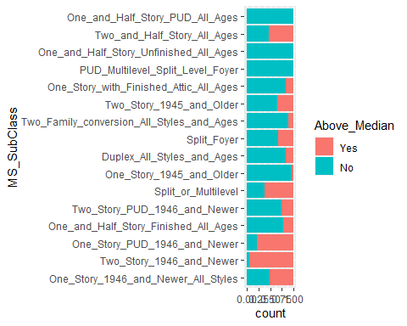

ggplot(Iowa, aes(x=MS_Zoning, fill=Above_Median))+geom_bar(position="fill")+coord_flip()

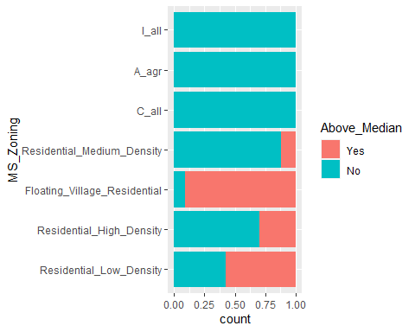

ggplot(Iowa, aes(x=Above_Median, y=Lot_Frontage))+geom_boxplot()

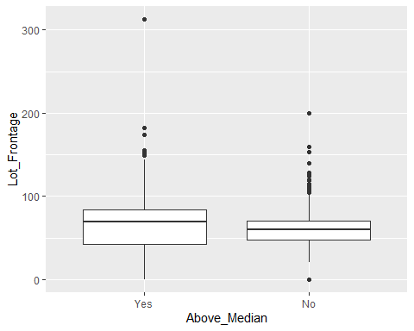

ggplot(Iowa, aes(x=Above_Median, y=Lot_Area))+geom_boxplot()

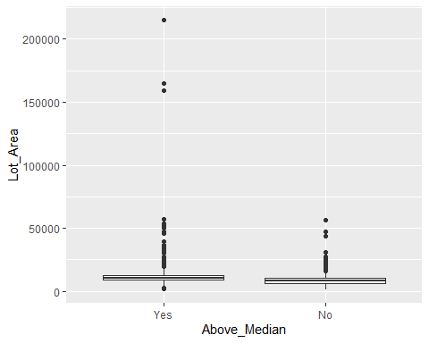

ggplot(Iowa, aes(x=Lot_Shape, fill=Above_Median))+geom_bar(position="fill")+coord_flip()

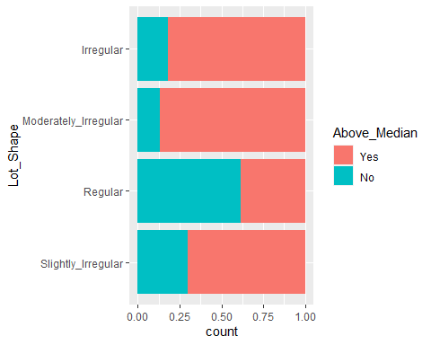

ggplot(Iowa, aes(x=Neighborhood, fill=Above_Median))+geom_bar(position="fill")+coord_flip()

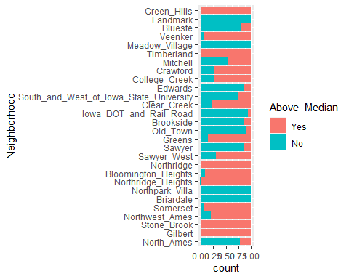

ggplot(Iowa, aes(x=Condition_1, fill=Above_Median))+geom_bar(position="fill")+coord_flip()

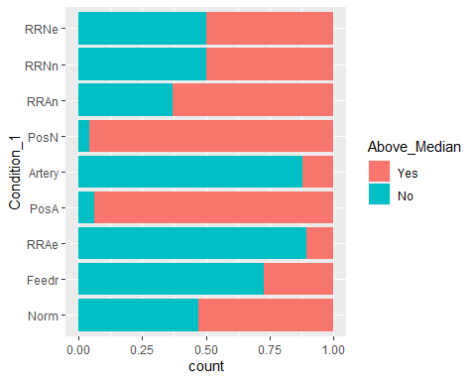

ggplot(Iowa, aes(x=Bldg_Type, fill=Above_Median))+geom_bar(position="fill")+coord_flip()

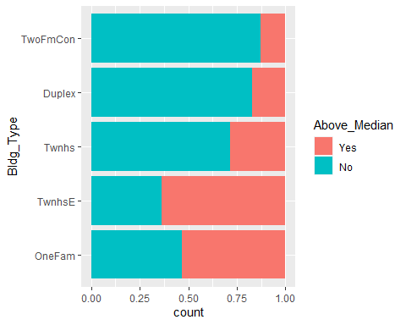

ggplot(Iowa, aes(x=House_Style, fill=Above_Median))+geom_bar(position="fill")+coord_flip()

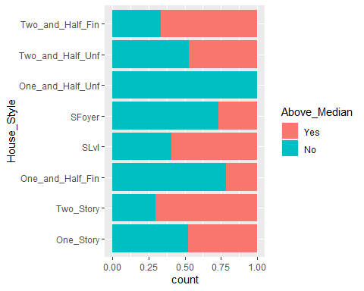

ggplot(Iowa, aes(x=Overall_Qual, fill=Above_Median))+geom_bar(position="fill")+coord_flip()

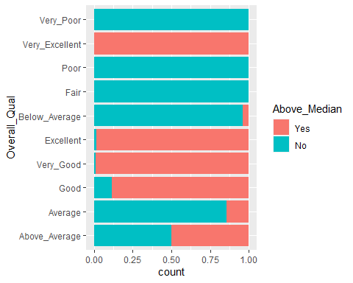

ggplot(Iowa, aes(x=Overall_Cond, fill=Above_Median))+geom_bar(position="fill")+coord_flip()

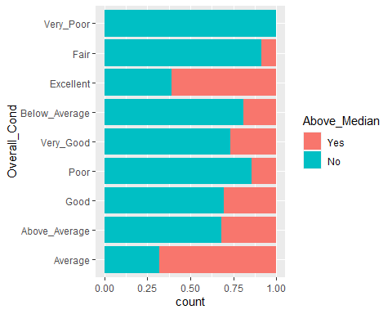

ggplot(Iowa, aes(x=Year_Built, fill=Above_Median))+geom_bar(position="fill")+coord_flip()

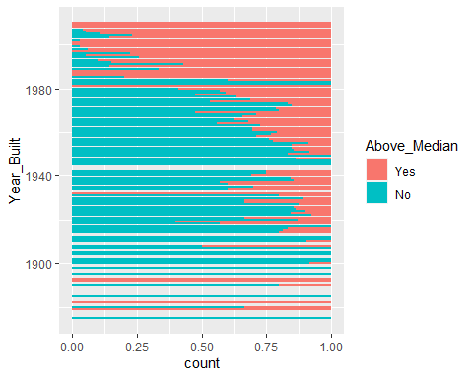

ggplot(Iowa, aes(x=Year_Remod_Add, fill=Above_Median))+geom_bar(position="fill")+coord_flip()

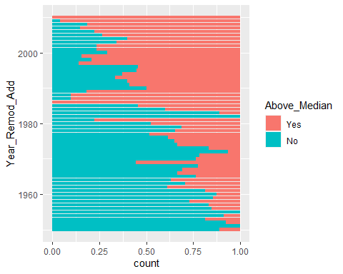

ggplot(Iowa, aes(x=Exterior_1st, fill=Above_Median))+geom_bar(position="fill")+coord_flip()

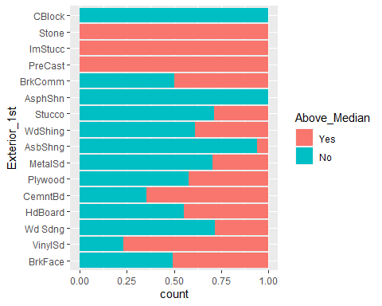

ggplot(Iowa, aes(x=Exterior_2nd, fill=Above_Median))+geom_bar(position="fill")+coord_flip()

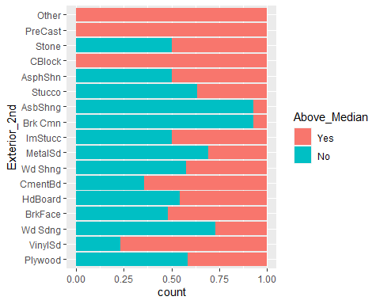

ggplot(Iowa, aes(x=Mas_Vnr_Type, fill=Above_Median))+geom_bar(position="fill")+coord_flip()

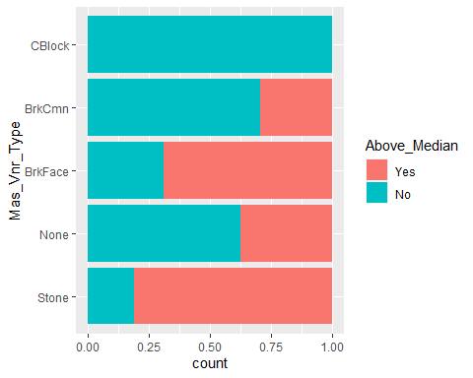

ggplot(Iowa, aes(x=Exter_Qual, fill=Above_Median))+geom_bar(position="fill")+coord_flip()

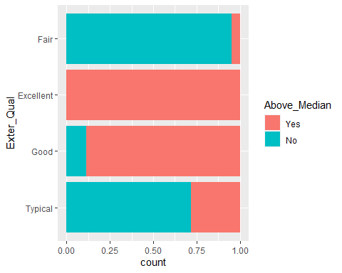

ggplot(Iowa, aes(x=Exter_Cond, fill=Above_Median))+geom_bar(position="fill")+coord_flip()

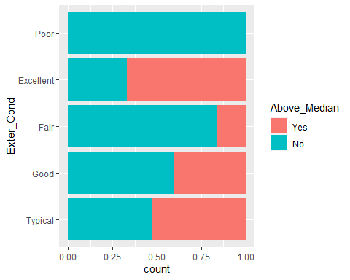

ggplot(Iowa, aes(x=Foundation, fill=Above_Median))+geom_bar(position="fill")+coord_flip()

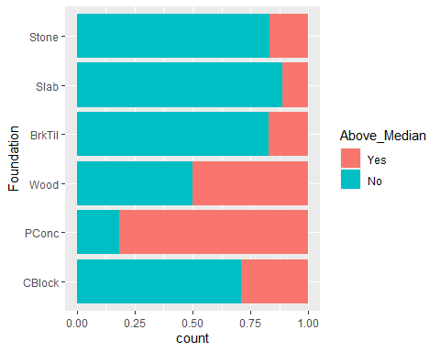

ggplot(Iowa, aes(x=Bsmt_Qual, fill=Above_Median))+geom_bar(position="fill")+coord_flip()

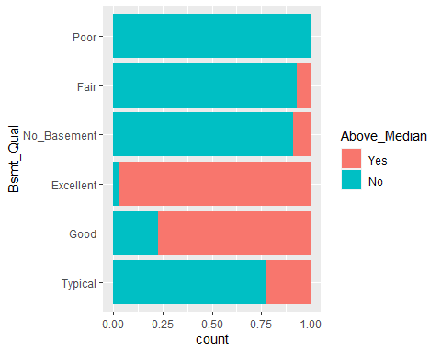

ggplot(Iowa, aes(x=Bsmt_Cond, fill=Above_Median))+geom_bar(position="fill")+coord_flip()

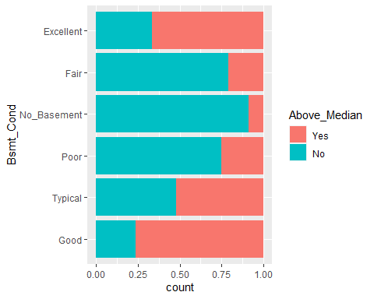

ggplot(Iowa, aes(x=Bsmt_Exposure, fill=Above_Median))+geom_bar(position="fill")+coord_flip()

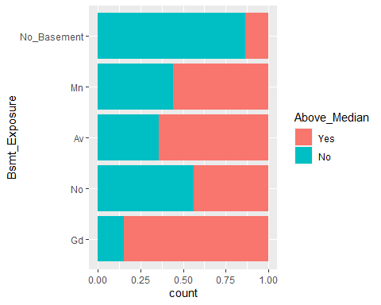

ggplot(Iowa, aes(x=BsmtFin_Type_1, fill=Above_Median))+geom_bar(position="fill")+coord_flip()

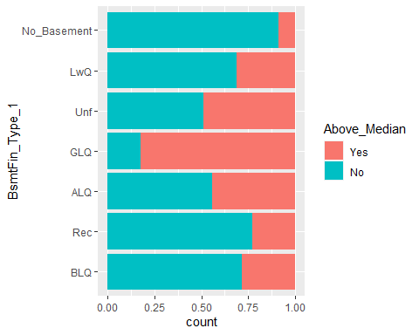

ggplot(Iowa, aes(x=BsmtFin_Type_2, fill=Above_Median))+geom_bar(position="fill")+coord_flip()

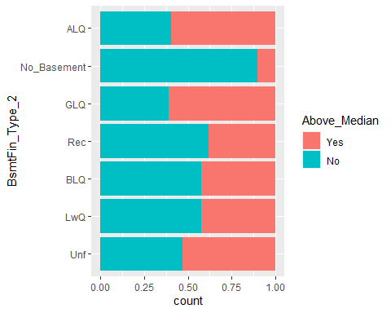

ggplot(Iowa, aes(x=Heating_QC, fill=Above_Median))+geom_bar(position="fill")+coord_flip()

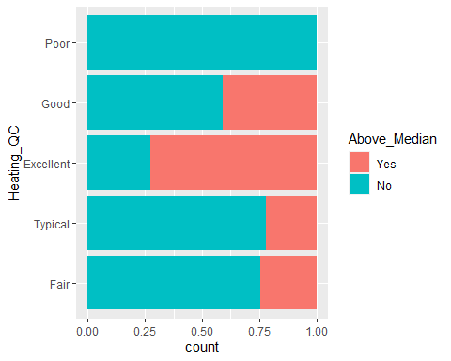

ggplot(Iowa, aes(x=Above_Median, y=First_Flr_SF))+geom_boxplot()

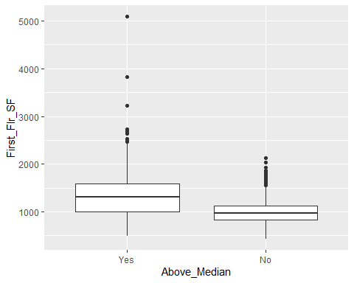

ggplot(Iowa, aes(x=Above_Median, y=Gr_Liv_Area))+geom_boxplot()

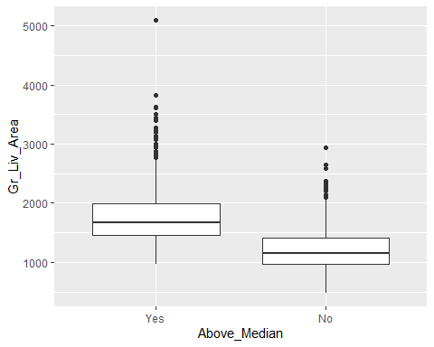

ggplot(Iowa, aes(x=Full_Bath, fill=Above_Median))+geom_bar(position="fill")+coord_flip()

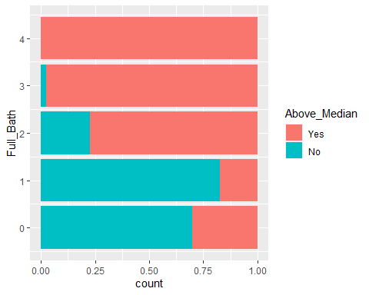

ggplot(Iowa, aes(x=Half_Bath, fill=Above_Median))+geom_bar(position="fill")+coord_flip()

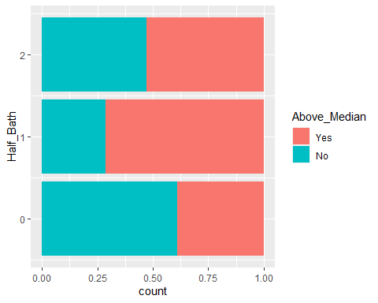

ggplot(Iowa, aes(x=Kitchen_Qual, fill=Above_Median))+geom_bar(position="fill")+coord_flip()

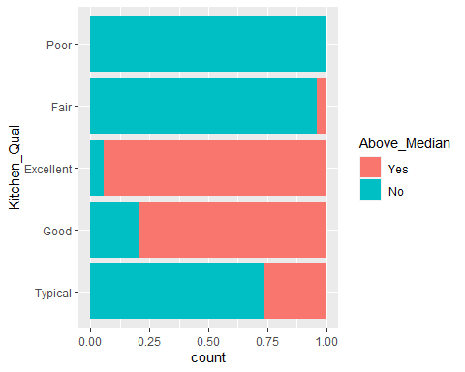

ggplot(Iowa, aes(x=TotRms_AbvGrd, fill=Above_Median))+geom_bar(position="fill")+coord_flip()

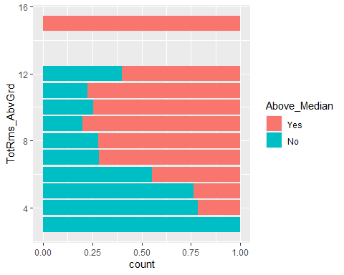

ggplot(Iowa, aes(x=Fireplace_Qu, fill=Above_Median))+geom_bar(position="fill")+coord_flip()

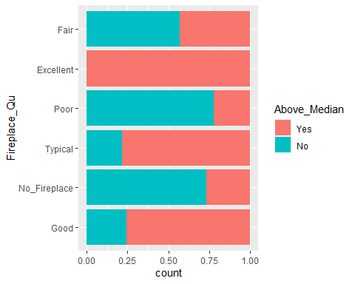

ggplot(Iowa, aes(x=Garage_Type, fill=Above_Median))+geom_bar(position="fill")+coord_flip()

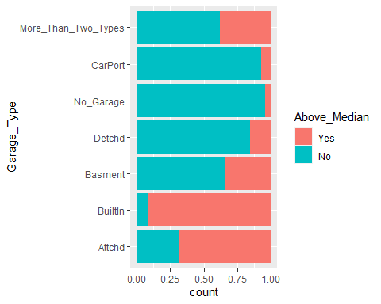

ggplot(Iowa, aes(x=Garage_Finish, fill=Above_Median))+geom_bar(position="fill")+coord_flip()

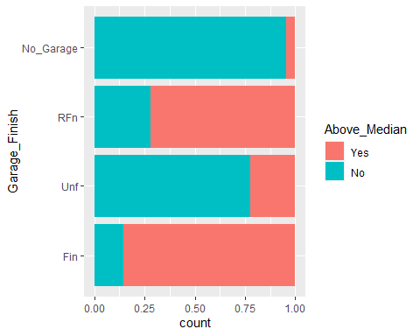

ggplot(Iowa, aes(x=Garage_Cars, fill=Above_Median))+geom_bar(position="fill")+coord_flip()

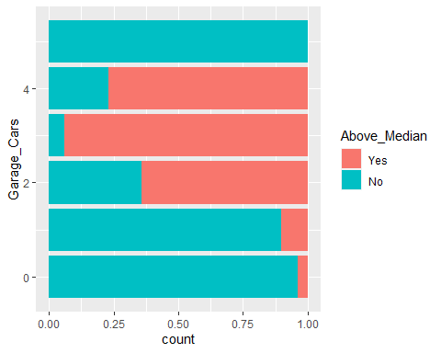

ggplot(Iowa, aes(x=Garage_Qual, fill=Above_Median))+geom_bar(position="fill")+coord_flip()

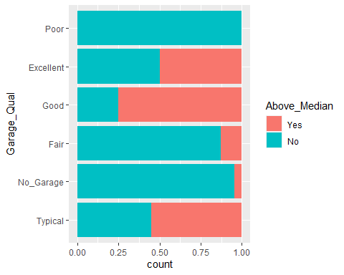

ggplot(Iowa, aes(x=Garage_Cond, fill=Above_Median))+geom_bar(position="fill")+coord_flip()

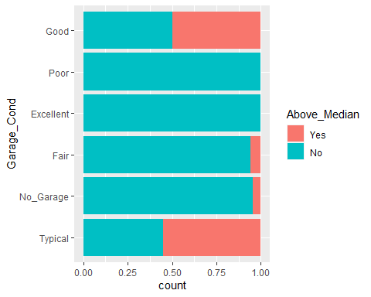

ggplot(Iowa, aes(x=Above_Median, y=Open_Porch_SF))+geom_boxplot()

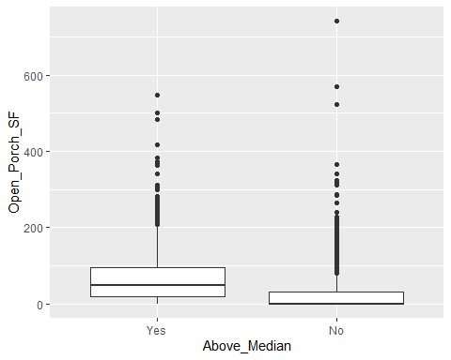

ggplot(Iowa, aes(x=Pool_QC, fill=Above_Median))+geom_bar(position="fill")+coord_flip()

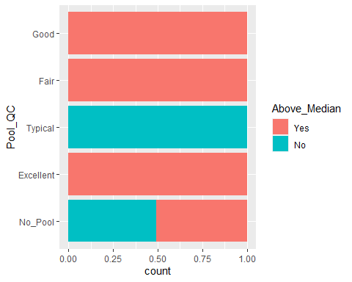

ggplot(Iowa, aes(x=Year_Sold, fill=Above_Median))+geom_bar(position="fill")+coord_flip()

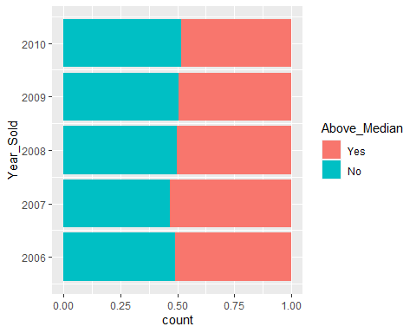

ggplot(Iowa, aes(x=Sale_Type, fill=Above_Median))+geom_bar(position="fill")+coord_flip()

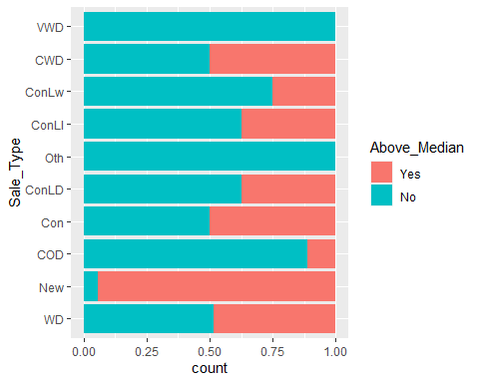

ggplot(Iowa, aes(x=Sale_Condition, fill=Above_Median))+geom_bar(position="fill")+coord_flip()

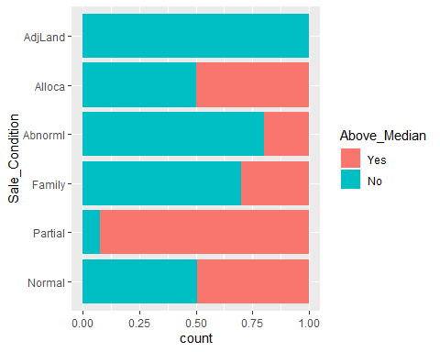

ggplot(Iowa, aes(x=Above_Median, y=First_Flr_SF))+geom_boxplot()

